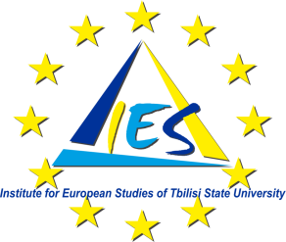
Establishing an Interdisciplinary PhD Programme in European Studies at Tbilisi State University
Launching ceremony
Wednesday May 1, 2013
10:00 a.m.– 12:00 p.m.
Hotel VERE PALACE,
22/24 Kuchishvili Str.0179, Tbilisi, Georgia

10:00 - 10:30 Welcome speeches
Mr. Alexander Kvitashvili, Rector of Tbilisi State University;;
Prof. Dr. Levan Alexidze, Deputy Rector of Tbilisi State University;;
Mr. Ramon Reigada Granda, Delegation of the European Union to Georgia, Head of Operations;
Dr. Diarmuid Rossa Phelan ,Trinity College Dublin;
Dr. Matteo FumagalliCentral European University;
Dr. Nevenka Maher, University of Ljubliana.
10:30 – 10:45 Presentation of the project by the Director of the Institute for European Studies of Tbilisi State University Mrs. Nino Lapiashvili
10:45 - 11:05 Questions and Answers Session
11:05 – 11:20 Graduation Ceremony of the MA students in European Studies;
11:20- 11:30 Closing remarks
11:30-12:00 Coffee

