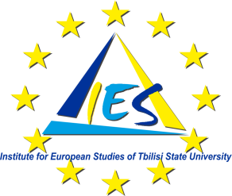

Press Release
On May the 1st, 2013 The Institute for European Studies of Tbilisi State University will mark the celebrations dedicated to Europe Day by launching the new project "PhD Programme in European Studies at Tbilisi State University", funded by the European Union. It will be followed by a two day conference/workshop on the same topic. The programme is enclosed.
In the same occasion, the Institute for European Studies of Tbilisi State University will present the most relevant objectives of the project followed by the Graduation Ceremony of Master’s students in European Studies.
The two day conference/workshop will be dedicated to the theoretical and practical aspects in the development of an interdisciplinary PhD programme in European Studies. Guests from partner international Universities will be present along with TSU academic society and invited experts.
Venue: VERE PALACE, 22/24 Kuchishvili Str.0179, Tbilisi, Georgia.
Start Time: 10 a.m.
Working Language: English (Translation into Georgian will be provided)
General Information: Institute for European Studies of TSU as the first interfaculty interdisciplinary unit running Master’s programme in European Studies- was established in 2007 with the financial support of European Union, within the framework of the TACIS programme.

